Task Title:
Cross-Region VPC Peering + Static Website Hosting with CDN, SSL & Custom Domain Setup
Objective:
Configure cross-region VPC peering, host a static website in S3, secure it with CloudFront + SSL, map a purchased domain using Route53, update content, and validate end-to-end connectivity.
Prerequisites
Before starting, ensure the following exist:
AWS Infrastructure
- Two VPCs in different regions
- Subnets in both VPCs
- Internet Gateway (if needed)
- Route Tables configured
- Security Groups
- IAM permissions (Admin or required permissions)
External Requirements
- One domain purchased from GoDaddy
- Basic HTML file (index.html)
AWS Services Needed
- S3 bucket (static website hosting enabled)
- ACM SSL Certificate (in us-east-1)
- CloudFront Distribution
- Route 53 Hosted Zone
- (Optional) Slack workspace for testing
Task on CloudFront & Route 53

1. Configure VPC peering in cross regions.
First create your vpc = virtual private cloud
Go aws account serach or you notice on recent click on vpc then redirect vpc dash in dash board you need click on create vpc
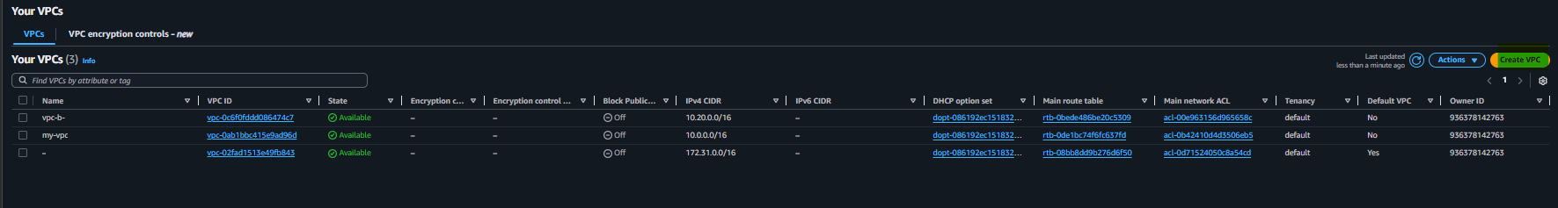
After click on vpc go in create vpc page
Give your name to vpc and add your ipv4 cidr in my case I have added 10.1.0.0/16 then leave everthing as defult setting click on create vpc

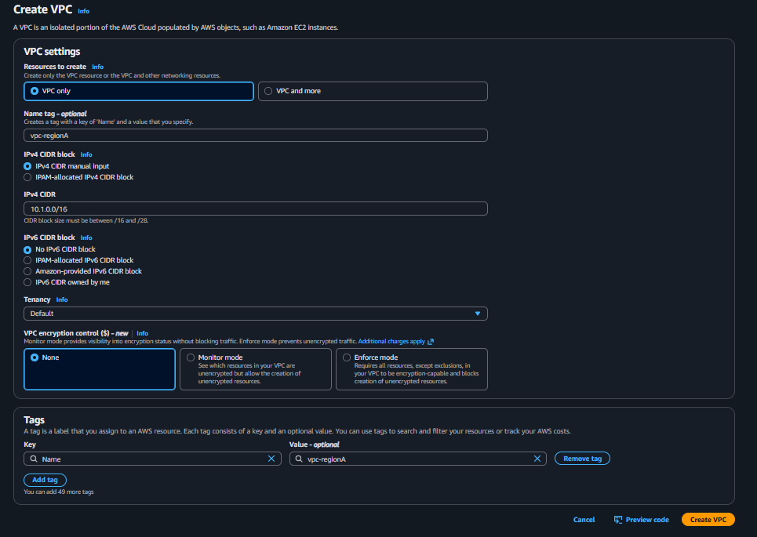

Now our vpc successfully create you see below all details on it
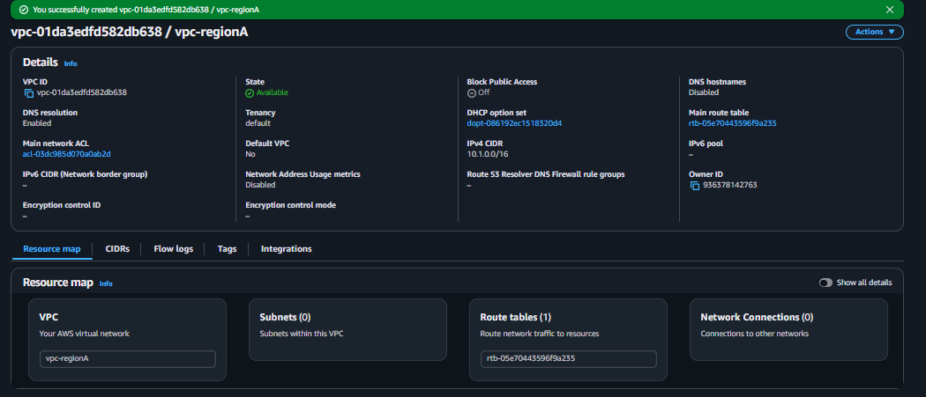

Now we need one more different region vpc lets create
First choice your vpc region in my case I select n.colifornia us-west-1
Then follow same steps that follow on our first vpc
So click on create vpc
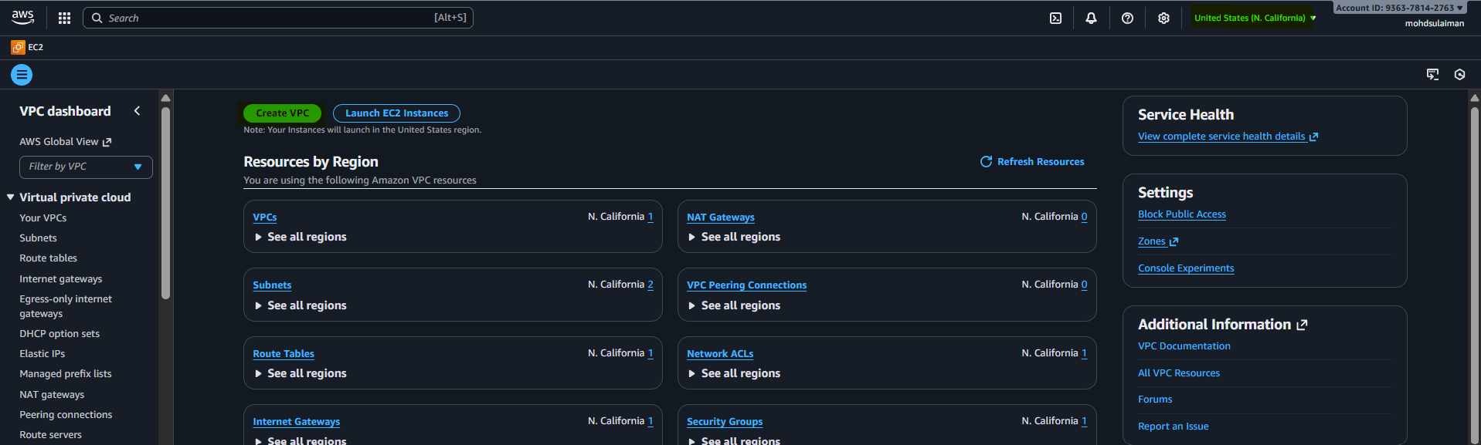
After give it in case I have given it vpc-regionB and also give it ipv4 subnet 10.2.0.0/16
That’s it now click on create
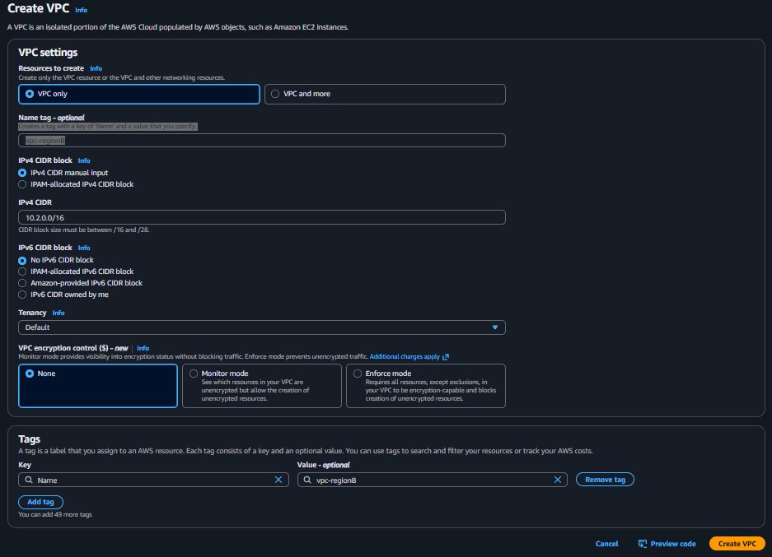
Now we successfully create second vpc
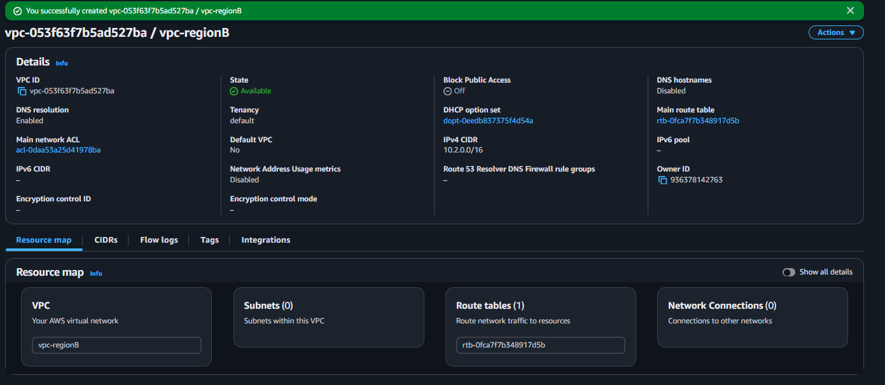
Now we have subnet with two different region next we need configure there subnets in each VPC
Lets create there subnets
To create subnet you will see left side vpc dash box click on subnet then click on create subnet
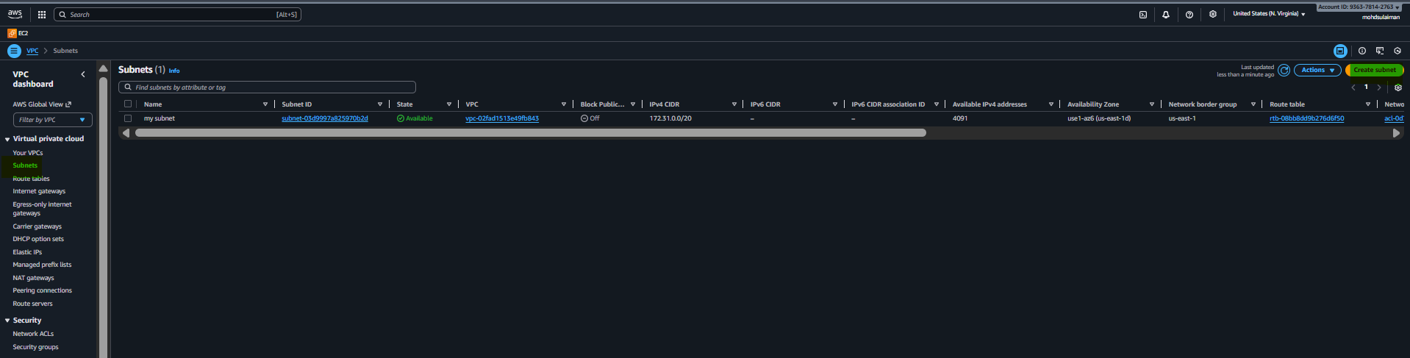Now select our vpc
Then give it subnet name in my case I give in it ( subnet-a-public)
Second choice Availability zone
Then give ipv4 subnet cidr block
After fulling ur detail click on create subnet

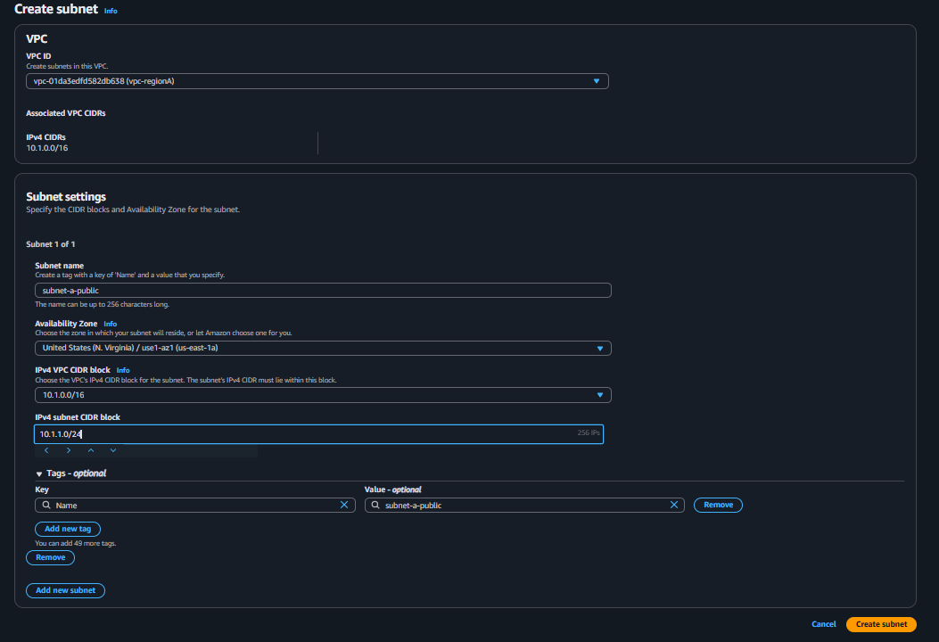
Now our subnet is successfully create now same follow second vpc
Our second subnet
Same follow same steps that follow in a subnet
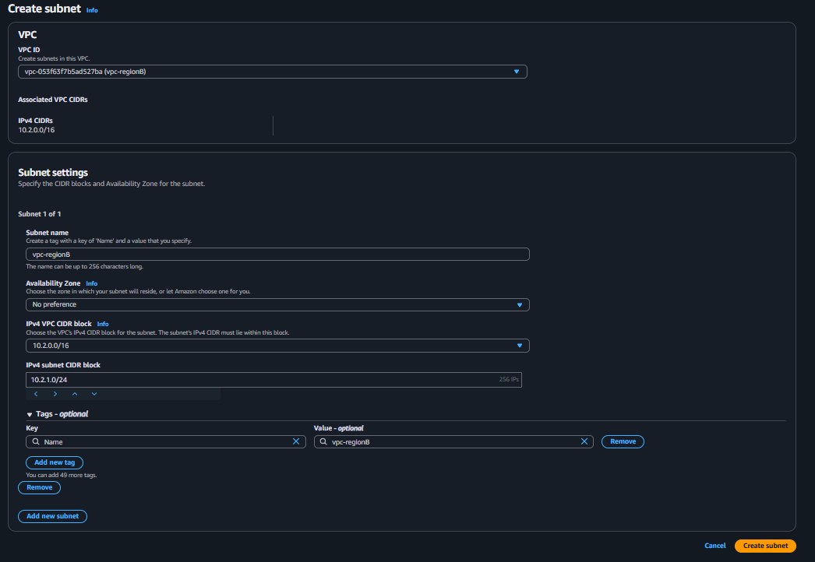
Now second subnet also successfully create
Now we Create route tables and attach subnets
To create route go route table section
Then click on create route table
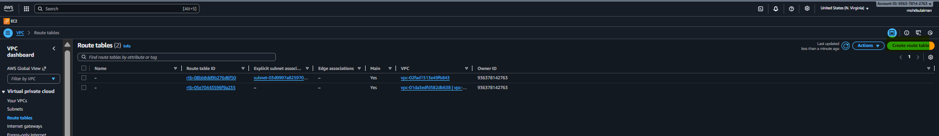
Now gibe your route table name
Select your vpc
Then click on create route table
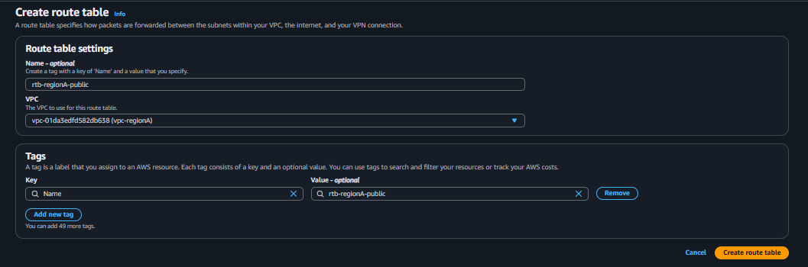
Now we subnet also click on subnet assorciation attach your vpc then click save
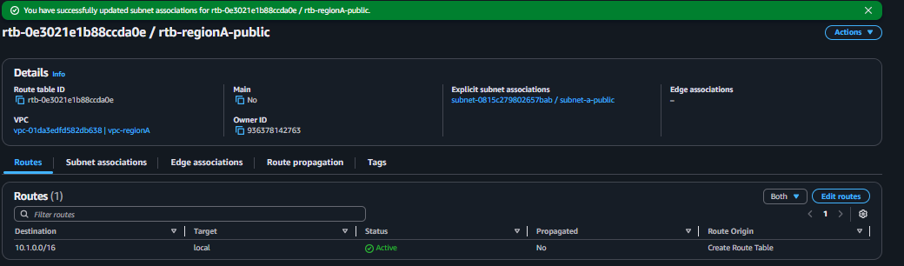
Follow the same steps that we follow (A) after that click on create route table
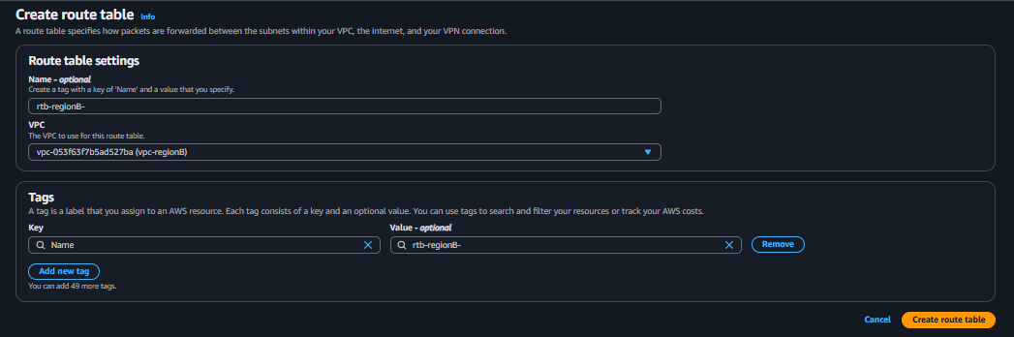
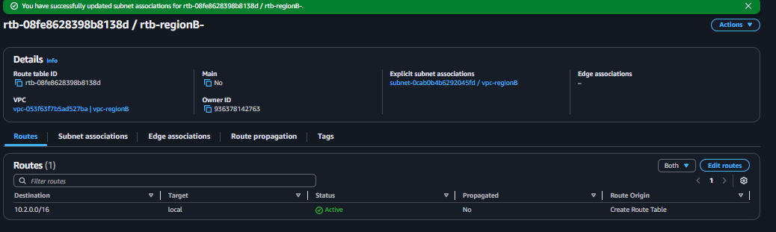
Now we need to Create Internet Gateway
First go internet gateway section
The next go create internet gateway
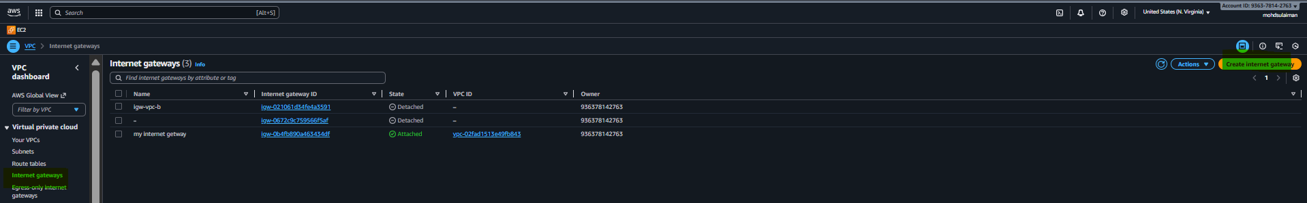
Now give any name tag in my case I have give igw-regionA after that click on create internet gateway
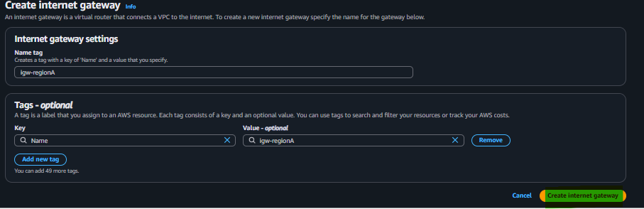
Now we successfully create igw = ( internet gateway )
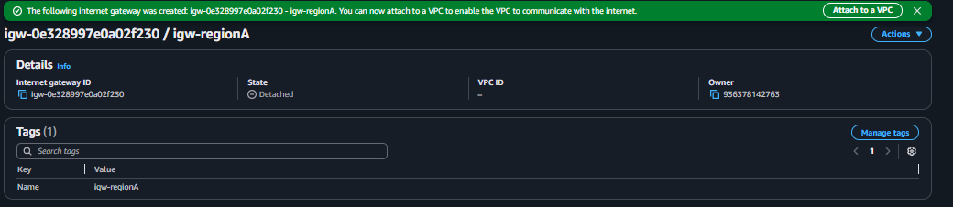
Now goes route table click on
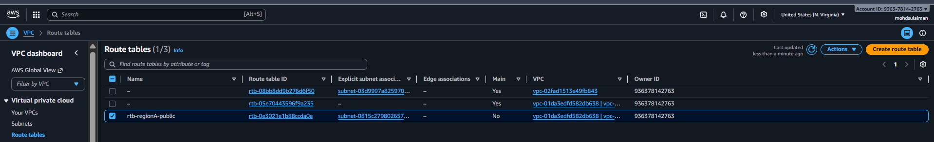
Now goes box click on edit routes
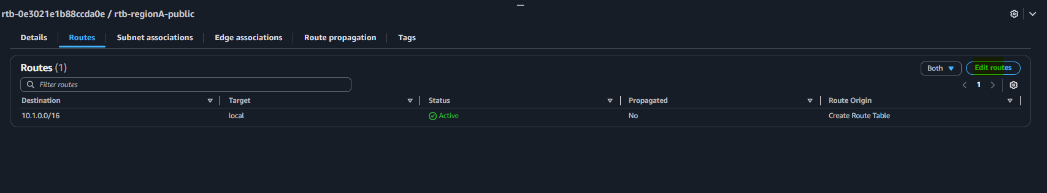
Now make sure attach your vpc click on attach to vpc
Now select your vpc and attach then click on internet gateway
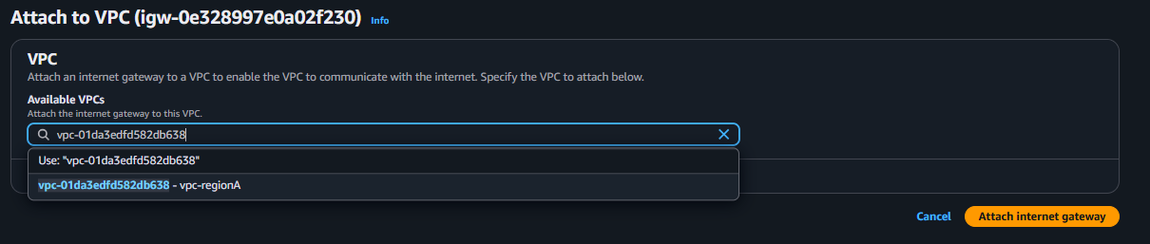
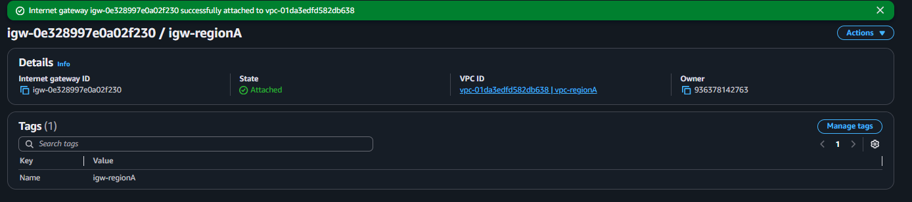
Now select 0.0.0.0/0 then give it internet gateway then click on save changes
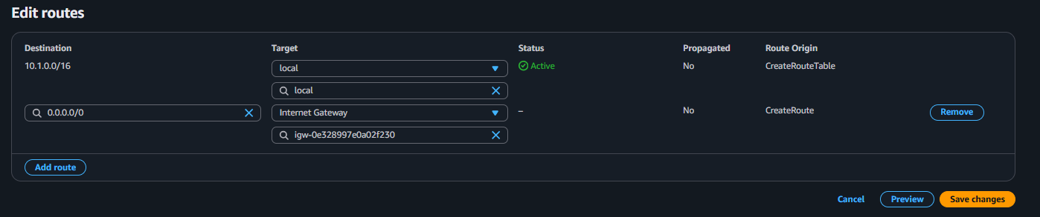
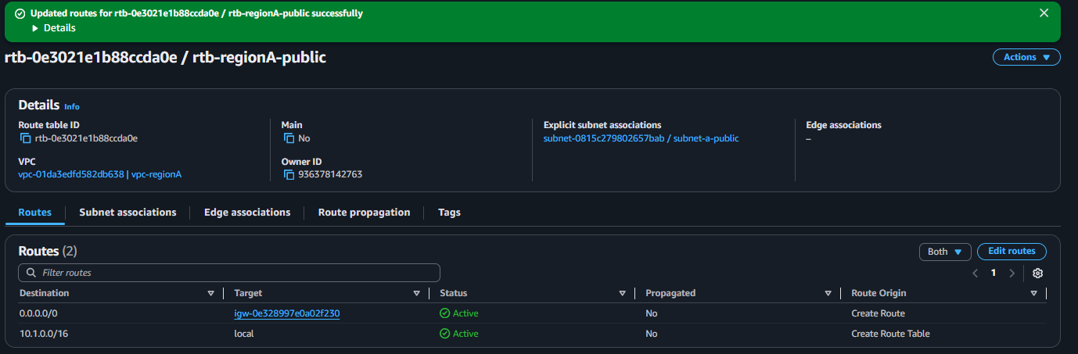
Now we need configure another vpc
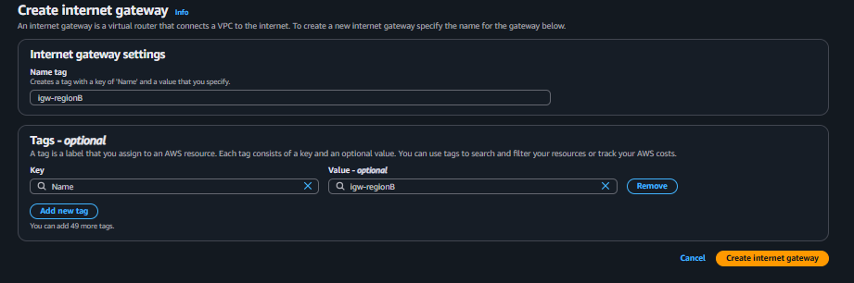
Attah vpc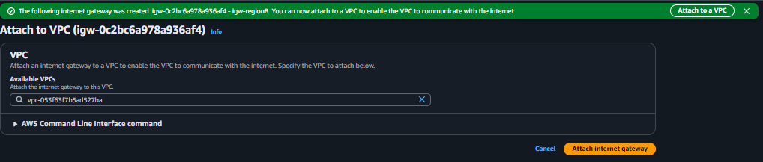
That’s it now click on save changes
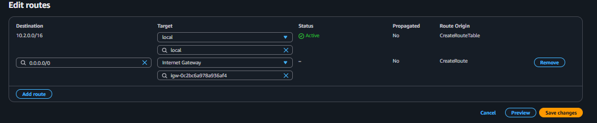
Create security groups for testing
First scroll down see security groups click on it then click on create security groups
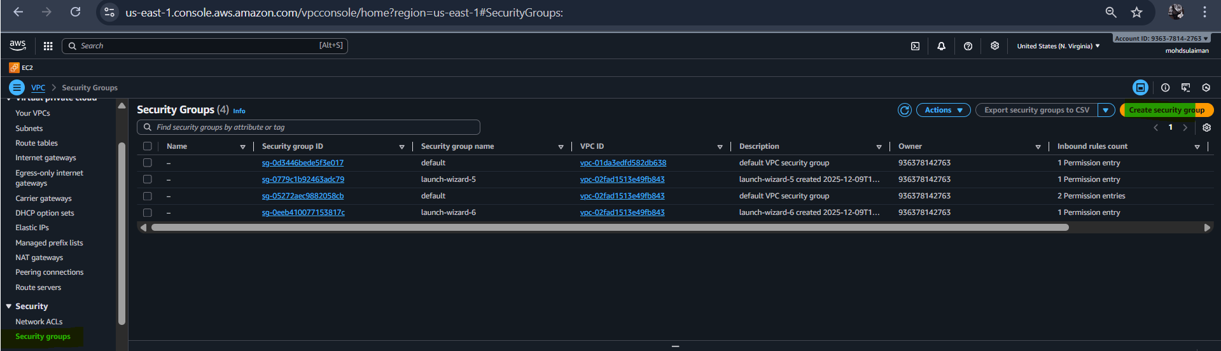
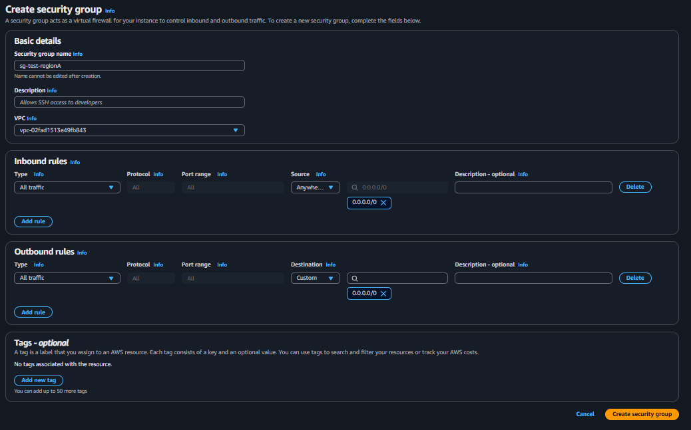
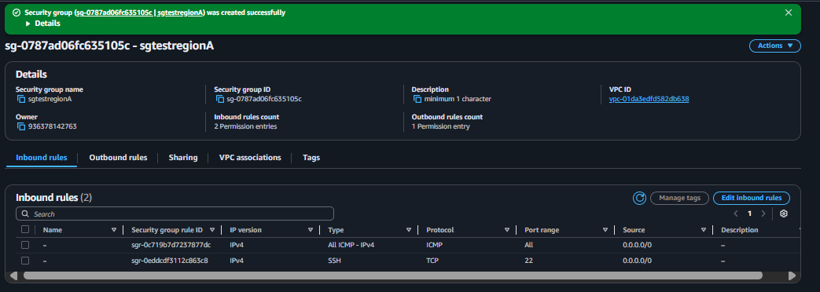

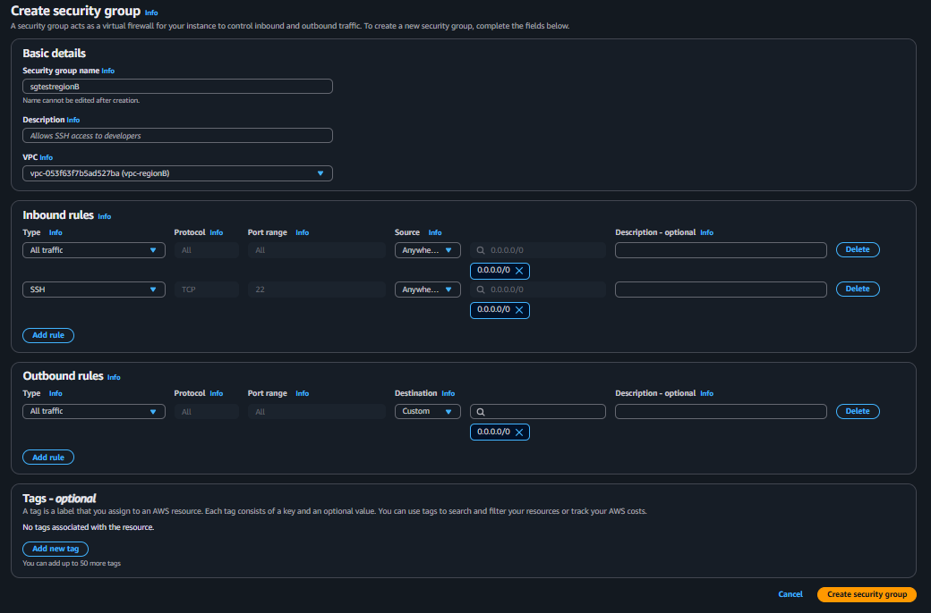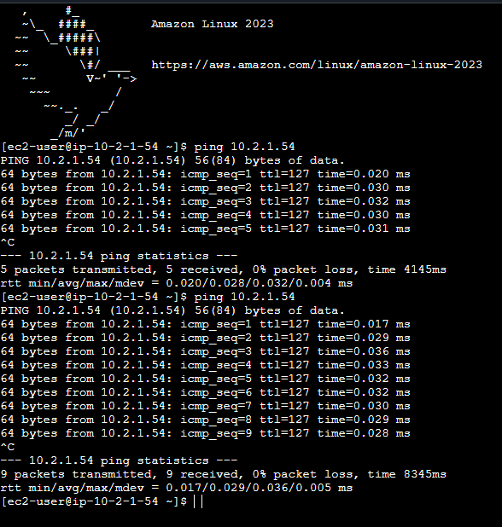

2. Purchase one domain from GoDaddy
First go on godaddy site
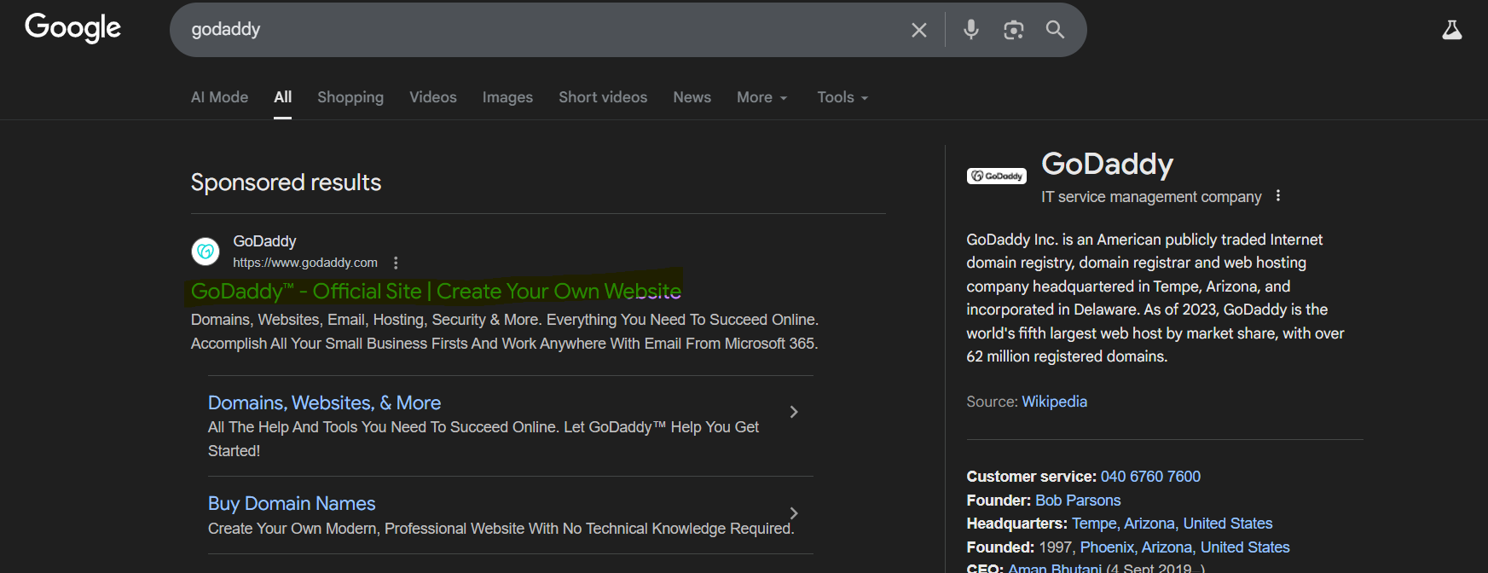
Now login in it
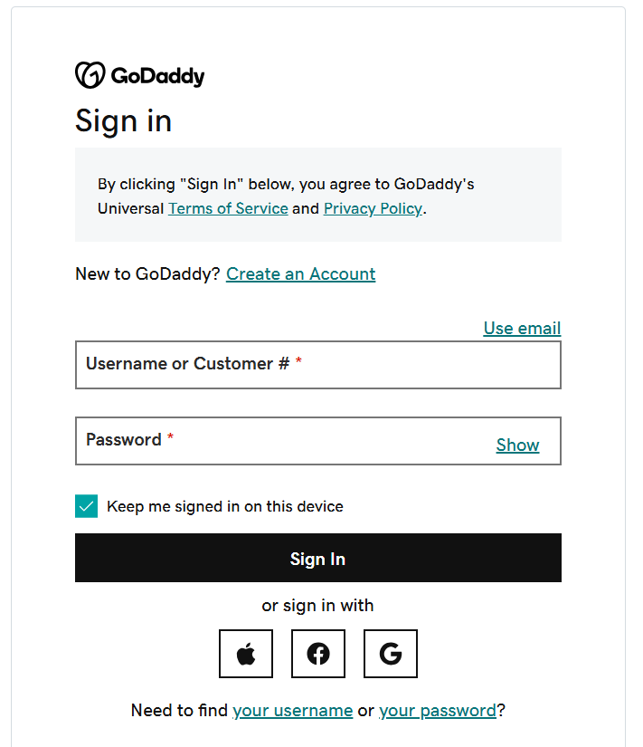

Serach your dns name then purchase it

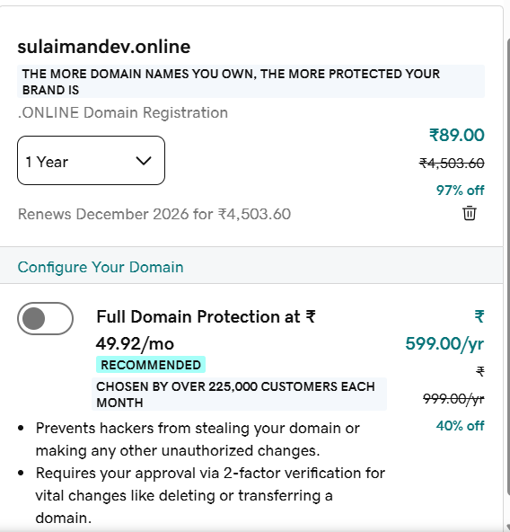

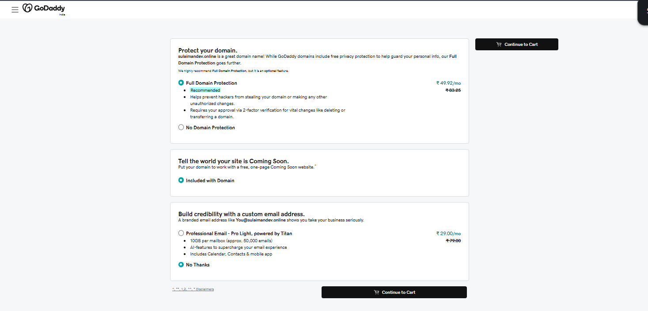
Select your purchase methood
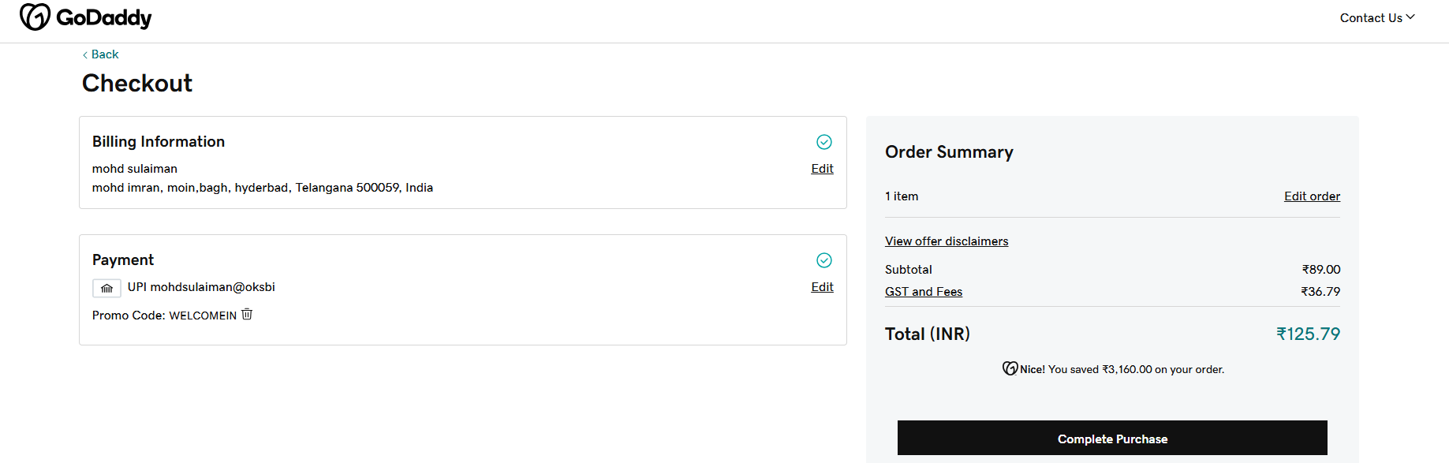
Now we successfully purchase dns

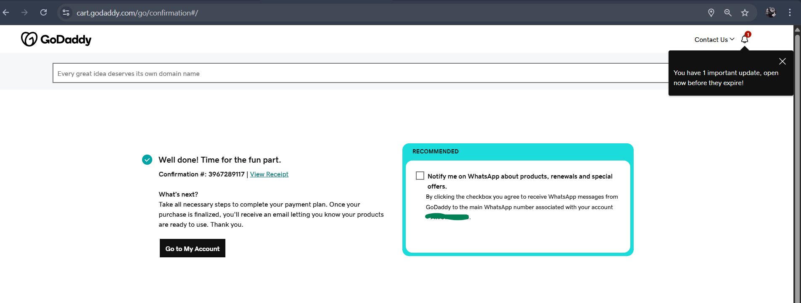
3. Deploy static website in S3.
To create bucket
Goes bucket section
Click on create bucket
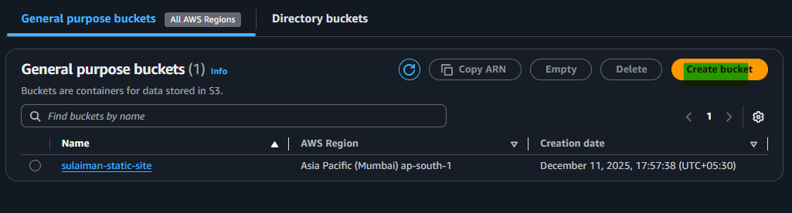
Now give your bucket name , also untick on block public access settings for this bucket
And tick on I acknowledge
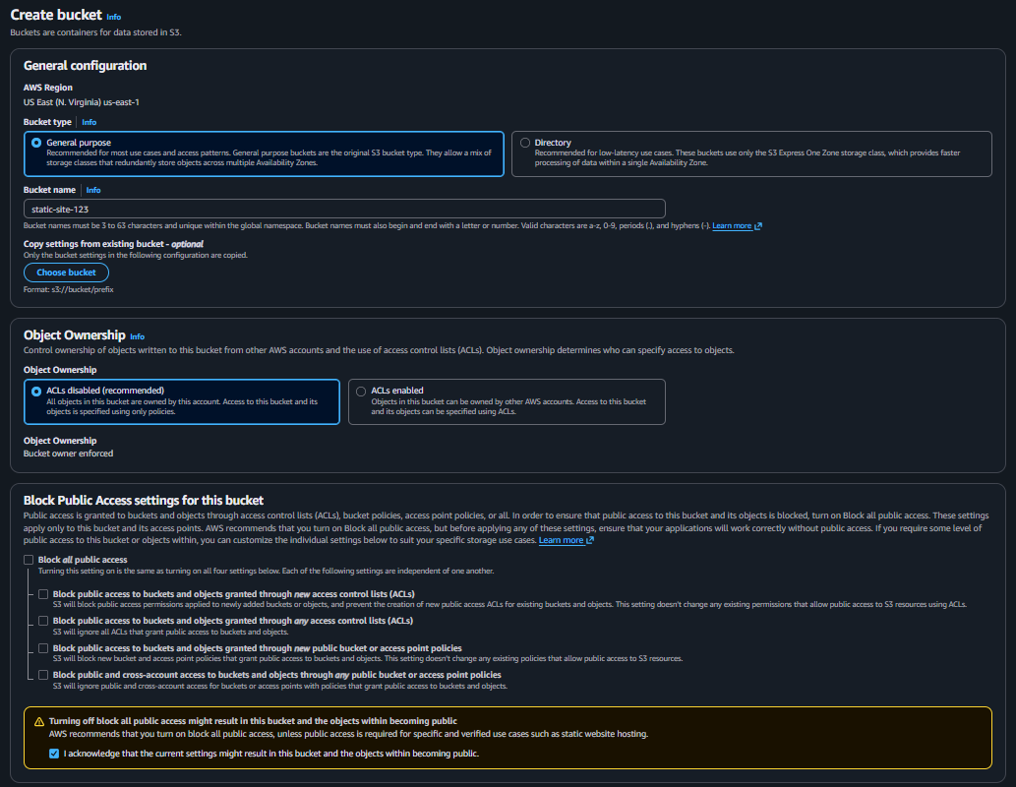
Now we have our bucket make sure you give unique name to your bucket
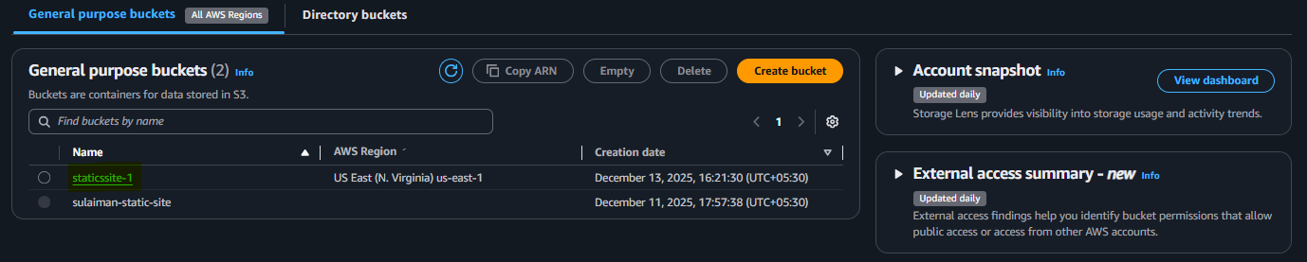
Now go inside your bucket upload html code
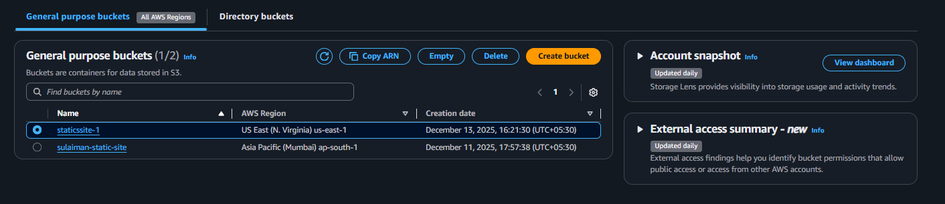
Now click on upload
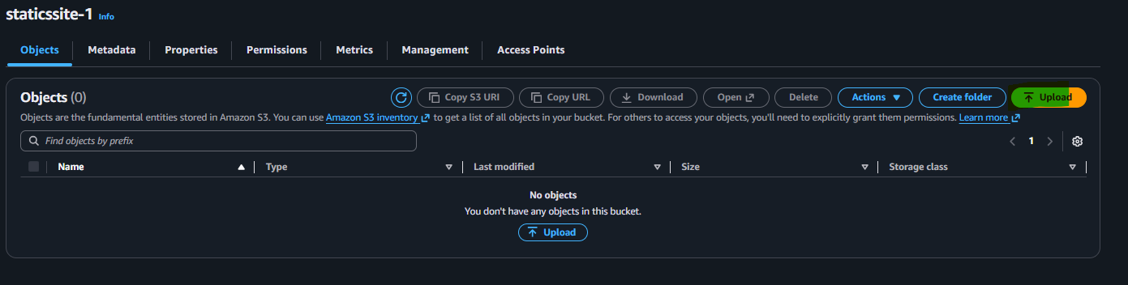
Now upload your file then click on upload
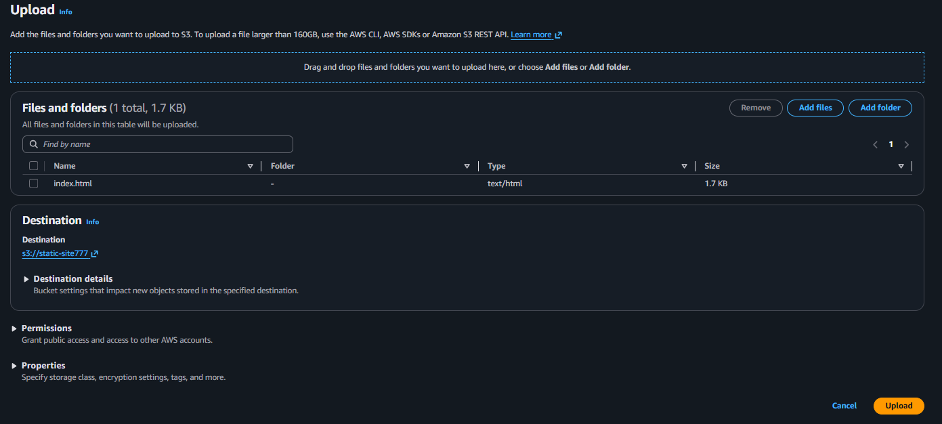
Now we have successfully upload it successfully
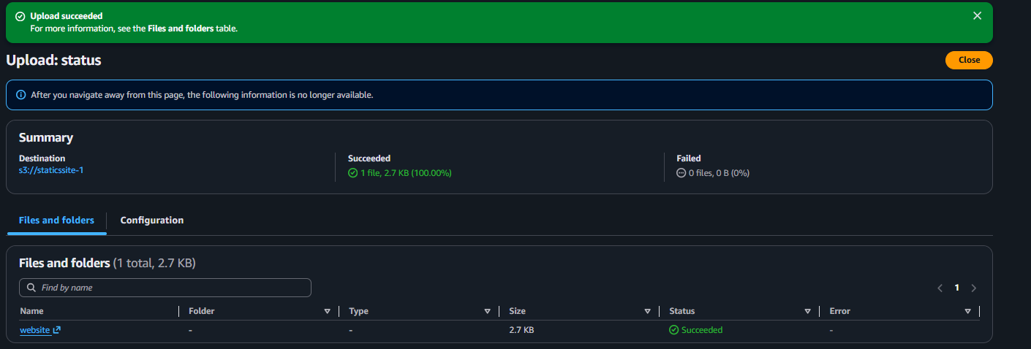
Add Bucket Policy Public Read
Allow enable
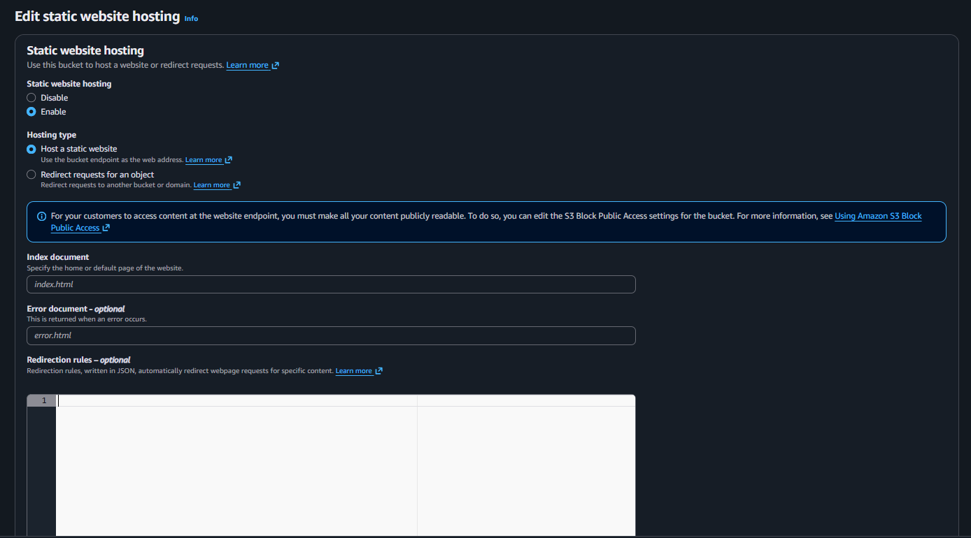

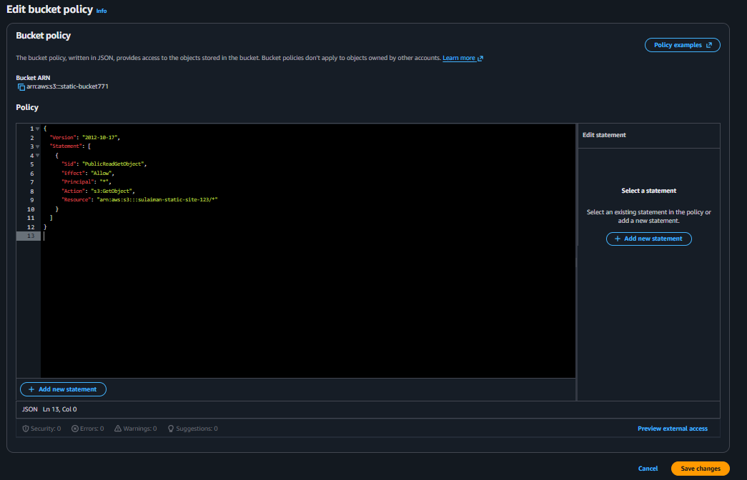
Now our static website working successfully

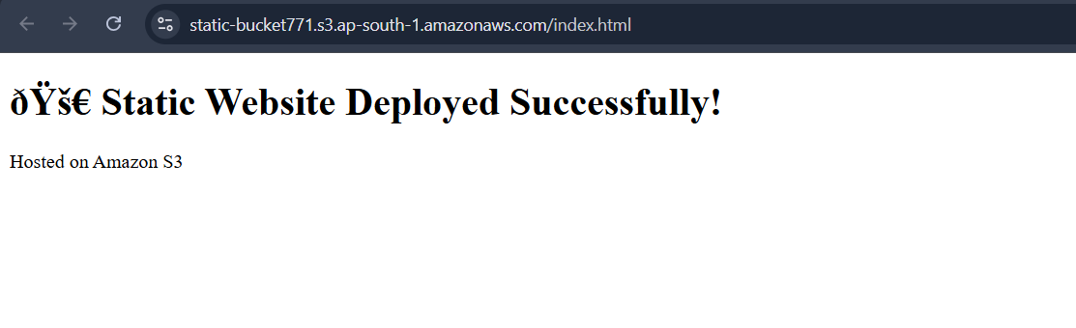

4 Create a CDN and attach one SSL certificate.
First go aws console serach CloudFront click on cloudfront
Then click on create distrubution
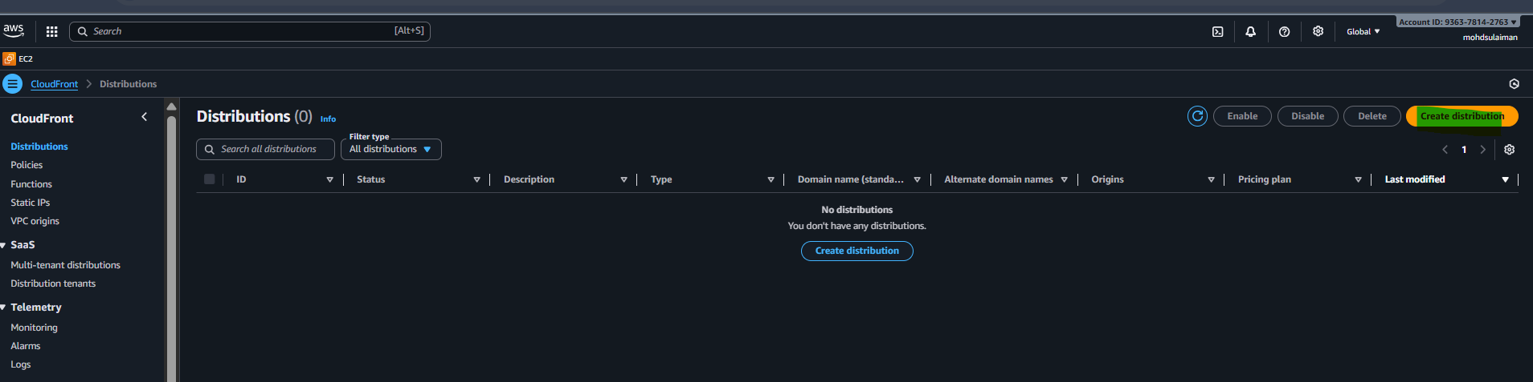
Now write distribution name in my case I written my name
Domain : sulaiman-devopseginner.online
Then click next

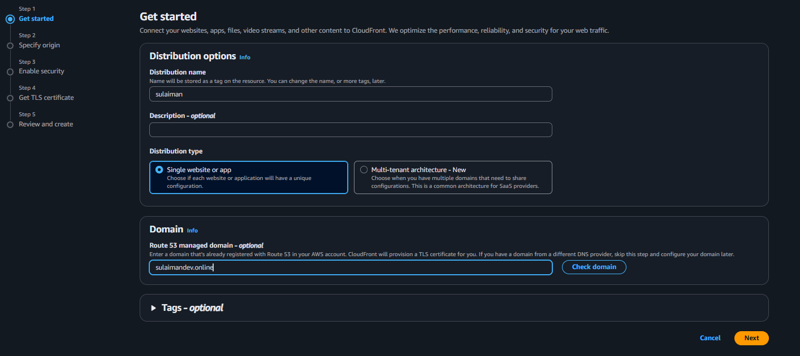
Now select cutomicze cache settins in that select ‘
Redirect http to https
Get head
That’s it click next

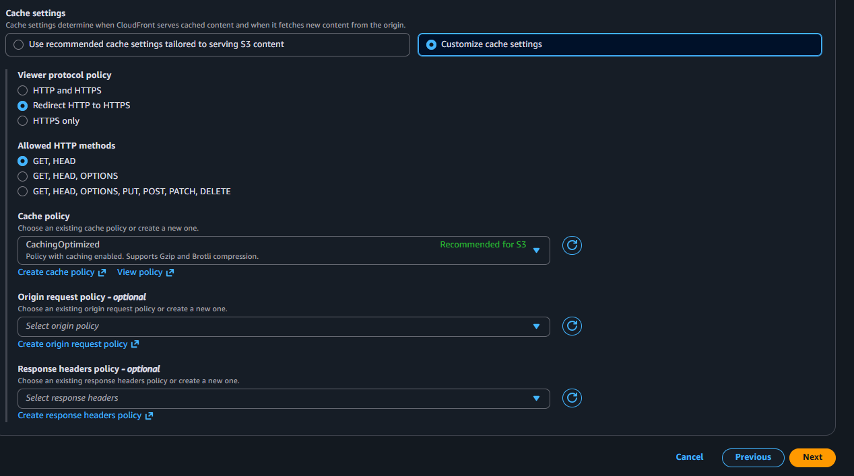
Enable security
For now it ok select do no enable security protection click next

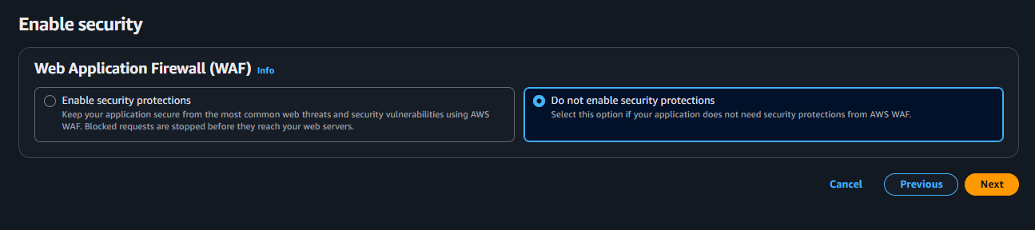
Now make sure verfy your all carefully if it correct click on create disturbution button

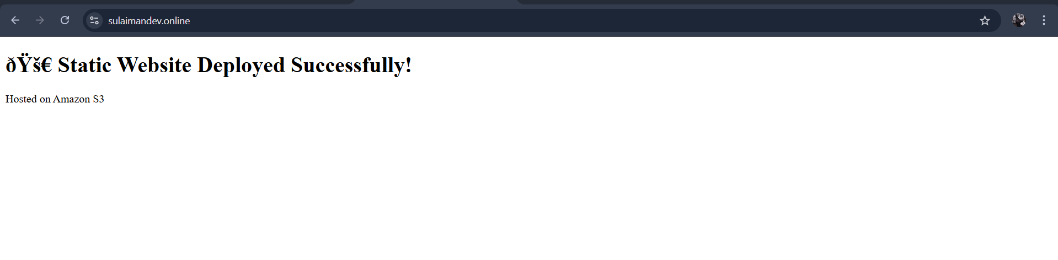

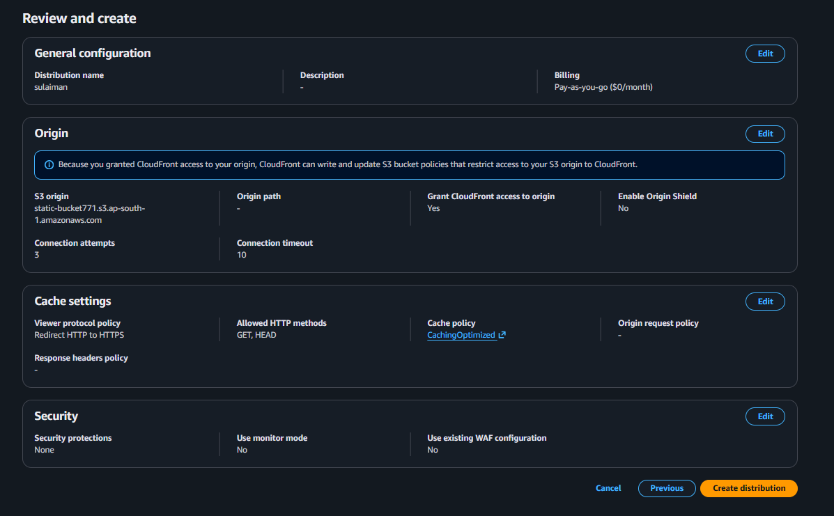
- That’s it We have attached SSL certificate to my CloudFront.

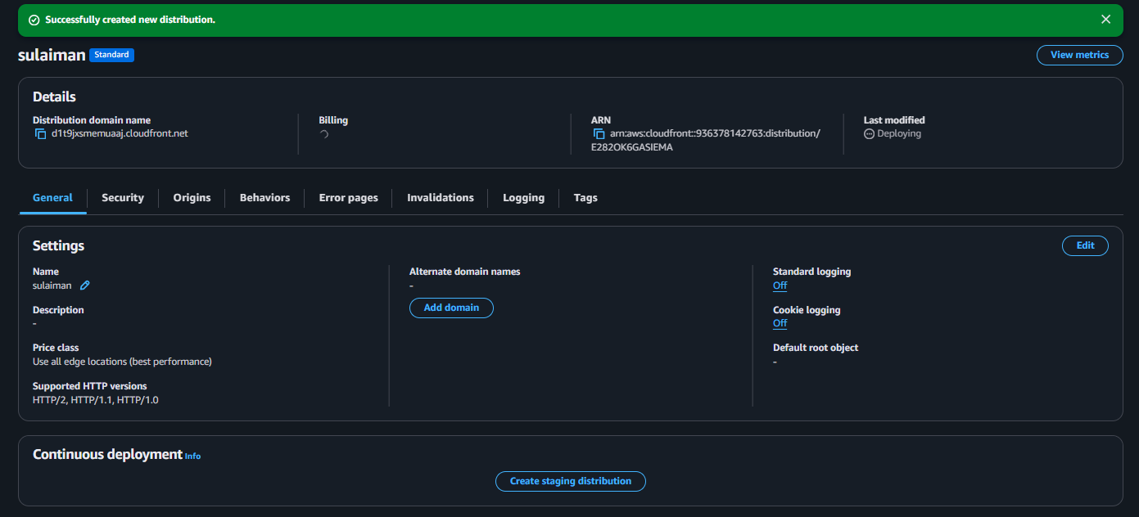

5 Create a Route 53 hosted zone and map the domain with the CDN.
First go aws console serach route53 click on it
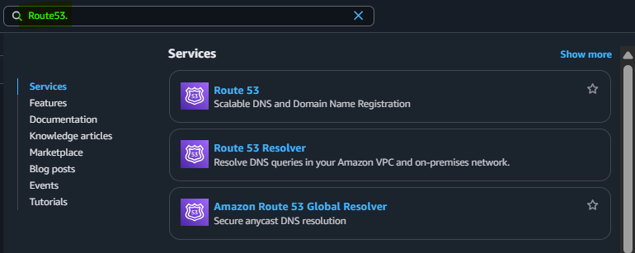
Now click on create hosted zone then get started
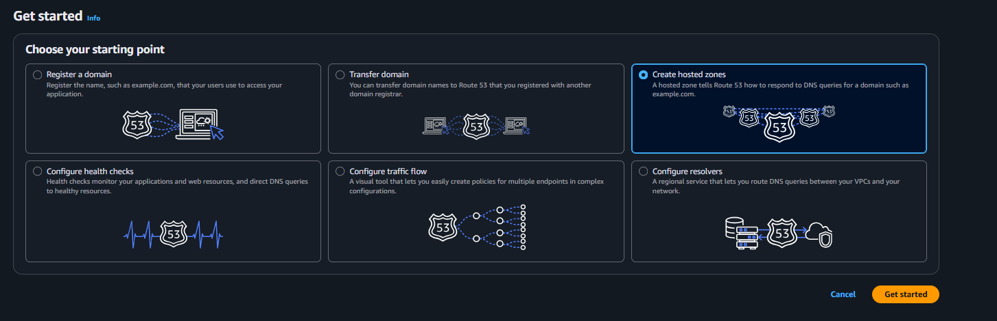
Then give domain name and click on create hosted zone
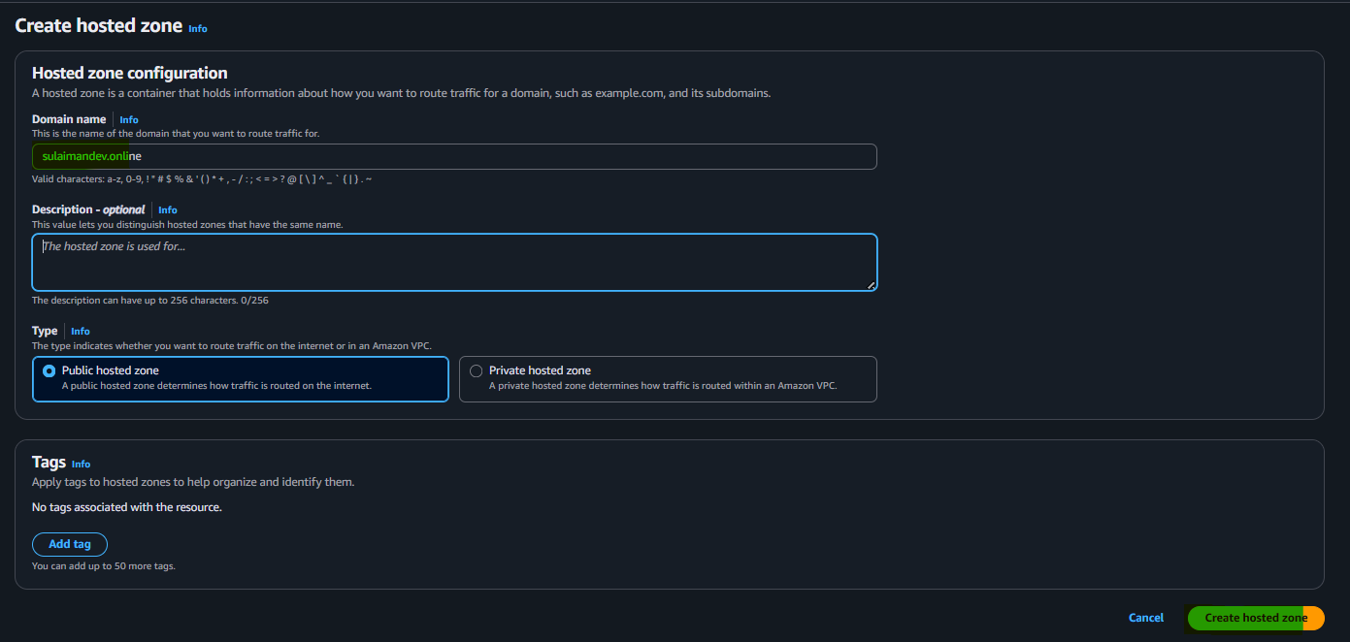
Now we successfully created
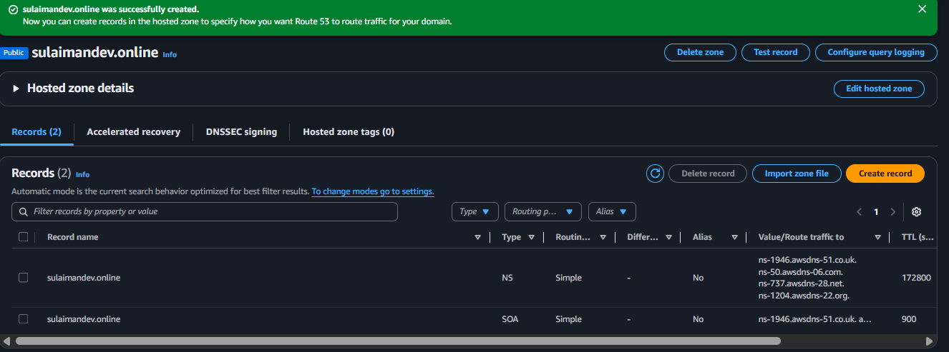
Now copy this ns-1946.awsdns-51.co.uk.
ns-50.awsdns-06.com.
ns-737.awsdns-28.net.
ns-1204.awsdns-22.org
ns-1946.awsdns-51.co.uk. awsdns-hostmaster.amazon.com. 1 7200 900 1209600 86400

NS values need to be copied over to GoDaddy website and paste it under DNS.
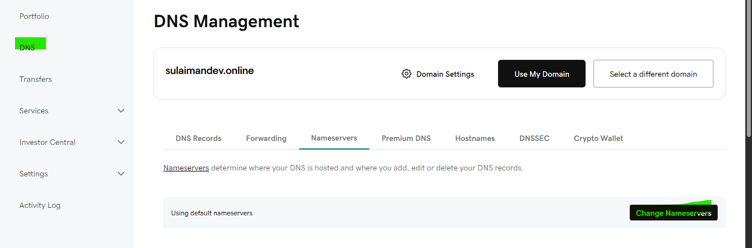
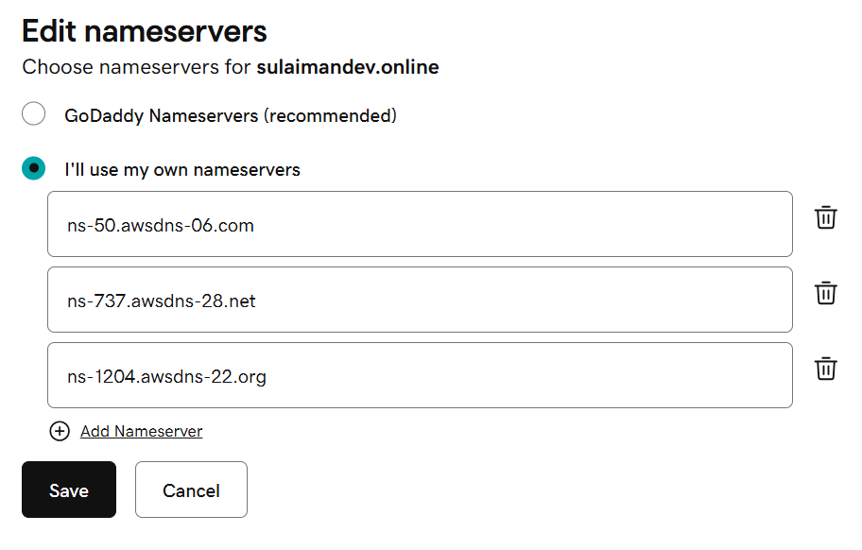
we can see the NS values have been added to DNS- Domian Name Server.

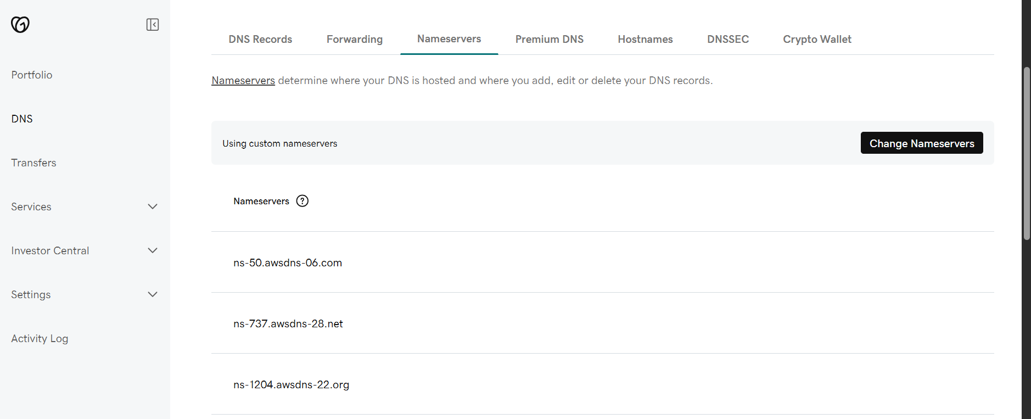

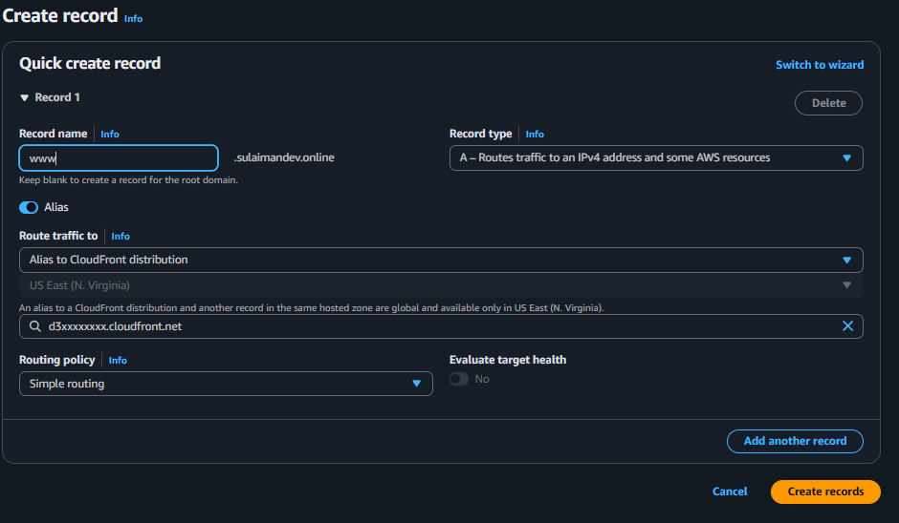

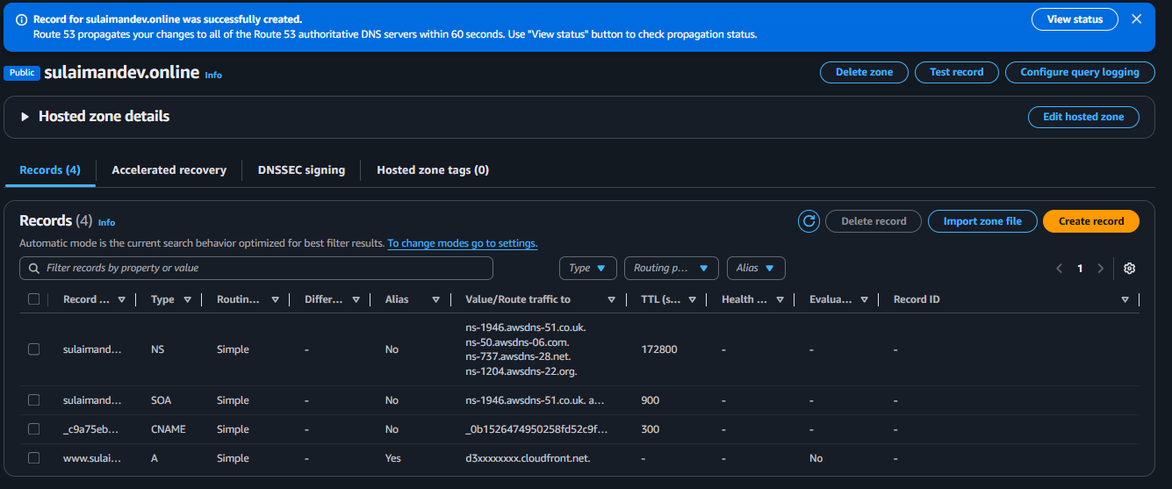

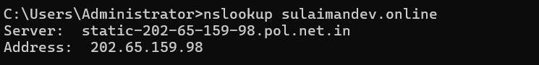
This is our R53 showing DNS routing is successful.
6. Update the index.html in the S3 bucket and ensure the updated file is accessible using the domain name.
Navigated to downloads where the index.html is present and updated the file using my requirements.
Once deleted the file in s3 and updated my file. My domain name opens with my updated content in index.html.
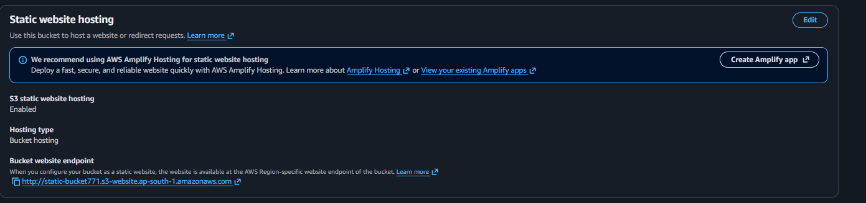

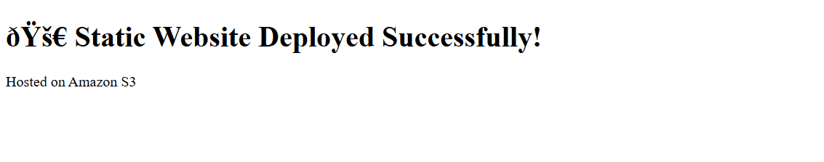
I deployed a static website on S3 by enabling static website hosting, uploading index.html, and validating it through the S3 website endpoint. HTTPS can be enabled using CloudFront.

